Largo

1. Operational Workflow & Compliance Issues
Pending Inquiry Checks:
No staff trained to perform these checks, leading to incomplete tests in the lab.
TAT (Turnaround Time) monitors fail to show Routine pending tests, causing delays.
Ingrid's responses are insufficient to resolve the issue.
Inventory/Supply Management:
Inefficient ordering system results in frequent reagent shortages.
Techs borrow supplies last-minute, causing test delays and stress.
Increased costs from Stat Courier Services and reliance on other labs (e.g., IOU list for Largo).
Lack of Clear Workflow Schedules:
No standardized duty lists or schedules for QC/maintenance across shifts (MOB/AUC labs).
Floaters lack guidance on daily tasks, leading to inconsistent operations.
2. Phlebotomy Productivity Gaps
Idle Time & Workflow Violations:
Data tools (e.g., Qmatic, Staff Performance Reports) reveal excessive idle time (e.g., 59-minute gaps between tickets).
Gaps suggest non-compliance with break schedules, workflow standards, or potential time fraud.
Wait times >0 indicate members waiting for phlebotomists, violating service protocols.
Corrective Action Challenges:
Productivity gaps trigger CA (Corrective Action) conversations but require multiple days of evidence (3–5 days).
Suspected time fraud necessitates badge swipe/camera footage reviews and HR involvement.
3. Chronic Staffing & Attendance Problems
High Absenteeism/Tardiness:
Frequent late arrivals (>5 mins), early departures (<30 mins), and unscheduled absences.
Staff cite sick leave, family emergencies, childcare issues, and traffic.
Corrective Action Overload:
Multiple employees on rolling-quarter CA tracking (e.g., Amy Mejia, Chantise Shark, Mia Mullins).
CA triggers vary: Some sites initiate at 3 incidents, others at 4.
FMLA/VOT complexities: Some staff fail to provide case numbers or follow callout protocols.
Operational Impact:
Unreliable staffing exacerbates workflow delays (e.g., pending inquiries, inventory shortages).
Sites like Kensington (KE), Northwest (NW), and Silver Spring (SS) show highest incident rates.
Key Interconnected Issues
Area
Root Cause
Impact
Workflow
Undefined processes, lack of training
Incomplete tests, TAT failures
Productivity
Idle time, break violations
Member wait times, service delays
Staffing
Absenteeism, tardiness, CA fatigue
Operational instability, increased costs
Inventory
Reactive ordering, poor tracking
Test delays, inter-lab dependencies
Recommended Actions
Standardize Training: Mandate training for Pending Inquiry checks and inventory management.
Optimize Scheduling: Implement clear shift duties, QC timelines, and break policies.
Data-Driven Oversight: Use ticket reports and attendance data to identify patterns (e.g., chronic tardiness, productivity gaps).
Attendance Policy Reform: Clarify CA triggers and enforce FMLA/VOT compliance.
Inventory System Overhaul: Automate reagent tracking and set reorder thresholds.
These issues collectively compromise lab efficiency, service quality, and staff accountability. Addressing them requires systemic changes in training, scheduling, and data utilization.

1. Pending Inquiry Checks
- Issue: No one is performing pending inquiry checks, and staff are unfamiliar with the process.
- Impact: Incomplete tests are received but not processed, and the TAT (Turnaround Time) monitor does not show routine pending tests.
- Suggestion: The senior tech (Ugochi) has offered to provide guidance via screenshots or in-person training.

2. Inefficient Inventory/Supplies System
- Issue: The current system for checking and ordering supplies is inefficient.
- Impact: Technicians frequently run out of reagents, leading to last-minute borrowing from other labs. This causes:
  - Delayed tests
  - Unnecessary stress
  - Time wasted calling other labs
  - Costs from stat courier services
- Evidence: Multiple IOU lists show items lent to other labs (e.g., Largo).

3. Lack of Clear Duties/Expectations/Workflow
- Issue: There is no clear list of duties, expectations, or workflow schedules for staff, including floaters.
- Impact: Staff are unsure what tasks to perform and when (e.g., QC times, maintenance, shift-specific duties for MOB and AUC labs).
- Suggestion: Ugochi has shared a sample duty list from a previous manager that could be adapted.

4. Chronic Attendance and Punctuality Issues
- Issue: Widespread and recurring attendance problems, including:
  - Late arrivals (>5 min)
  - Early departures
  - Unscheduled absences
  - Missed punches
  - Excessive use of VOT (Voluntary Time Off) and FMLA
- Impact:
  - Disrupted workflow
  - Increased burden on present staff
  - Need for frequent corrective actions and manager interventions
- Notable Trends:
  - Multiple employees have rolling attendance issues.
  - Some staff are on corrective action plans (CA1, CA2).
  - FMLA and call-out protocols are often misused or not followed.

5. Communication and Protocol Compliance
- Issue: Staff often fail to follow call-out procedures, notify client services, or provide required documentation (e.g., FMLA case numbers).
- Impact: Inefficient scheduling, last-minute coverage gaps, and administrative overhead.

🧠 Underlying Themes
- Lack of Standardization: In procedures, training, and scheduling.
- Inefficient Systems: Both in inventory and attendance tracking.
- Accountability Gaps: Staff are not consistently following protocols or fulfilling responsibilities.
- Leadership Visibility: Staff are unclear about expectations and lack guidance.

Critical Lab Issues Identified

1. Staff Performance & Behavioral Problems
Core Issues:
- Direct reports making frequent mistakes and hiding errors instead of reporting them
- Extremely slow turnaround times (TAT) - only 48-75% meeting targets vs 90% goal
- Staff avoiding QC and maintenance duties, claiming "don't know how" despite documented competencies
- Behavioral issues including disappearing from benches, extended unauthorized breaks
- Poor evening shift performance with specific underperformers (Sam mentioned as problematic lead tech)

2. Operational Inefficiencies
Specific Problems:
- Understaffing by 3.3 FTE affecting coverage
- Poor lab layout causing bottlenecks (Stago/hematology benches adjacent)
- 50% staff idle time indicating poor workflow management
- Missing specimens sitting for hours before processing
- No standardized procedures for critical processes

3. Quality Control Breakdown
Critical Gaps:
- Systematic avoidance of QC responsibilities
- Incomplete or falsified QC documentation
- No hard stops preventing instrument use without proper QC
- Lack of competency verification despite documented training

Summary of Lab Operations & Staffing Issues
The core issue is a struggle to meet key performance indicators (KPIs), primarily patient wait times, due to a combination of operational inefficiencies and staffing challenges. This creates a cycle where staffing problems worsen operations, and operational inefficiencies place more stress on staff.
1. Operational Inefficiencies:
- Inconsistent Processes: The lack of a formalized break schedule (as noted in Nate's goal for Fredericksburg) leads to unpredictable coverage and workflow disruptions.
- Tool Misuse: Staff are not consistently following the established workflow systems (e.g., Qmatic, the patient queue system), leading to inaccurate wait time data and inefficient patient routing.
- Turnaround Time (TAT) Variability: A significant percentage of routine tests (e.g., Chemistry) are outliers, exceeding target TATs. This suggests bottlenecks in the testing process, likely around analyzer maintenance, calibration schedules, or manual review steps.
- Data Lag: Leadership and supervisors lack real-time, automated visibility into performance metrics. They rely on manual data gathering, which is slow and prevents proactive intervention.
2. Staffing Challenges:
- Attendance & Reliability: A specific need for "corrective action for time and attendance issues" was explicitly stated. This indicates problems with punctuality, unplanned absences, or adherence to schedules, which directly cripples daily lab capacity.
- Coverage Gaps: The planned use of MLAs (Medical Laboratory Assistants) to cover phlebotomist breaks highlights a thin staffing model. The system is vulnerable to any unplanned absence.
- Unplanned Absences: PTO, sick leave, jury duty, and FMLA are cited as major risks that create immediate and critical coverage gaps, directly impacting wait times and potentially patient safety.
- Resistance to Change: The note about potential "staff pushback" against new processes (like changed calibration routines) indicates a cultural challenge in adopting new, more efficient workflows.

How These Issues Are Connected
The problems are deeply interconnected, creating a vicious cycle:
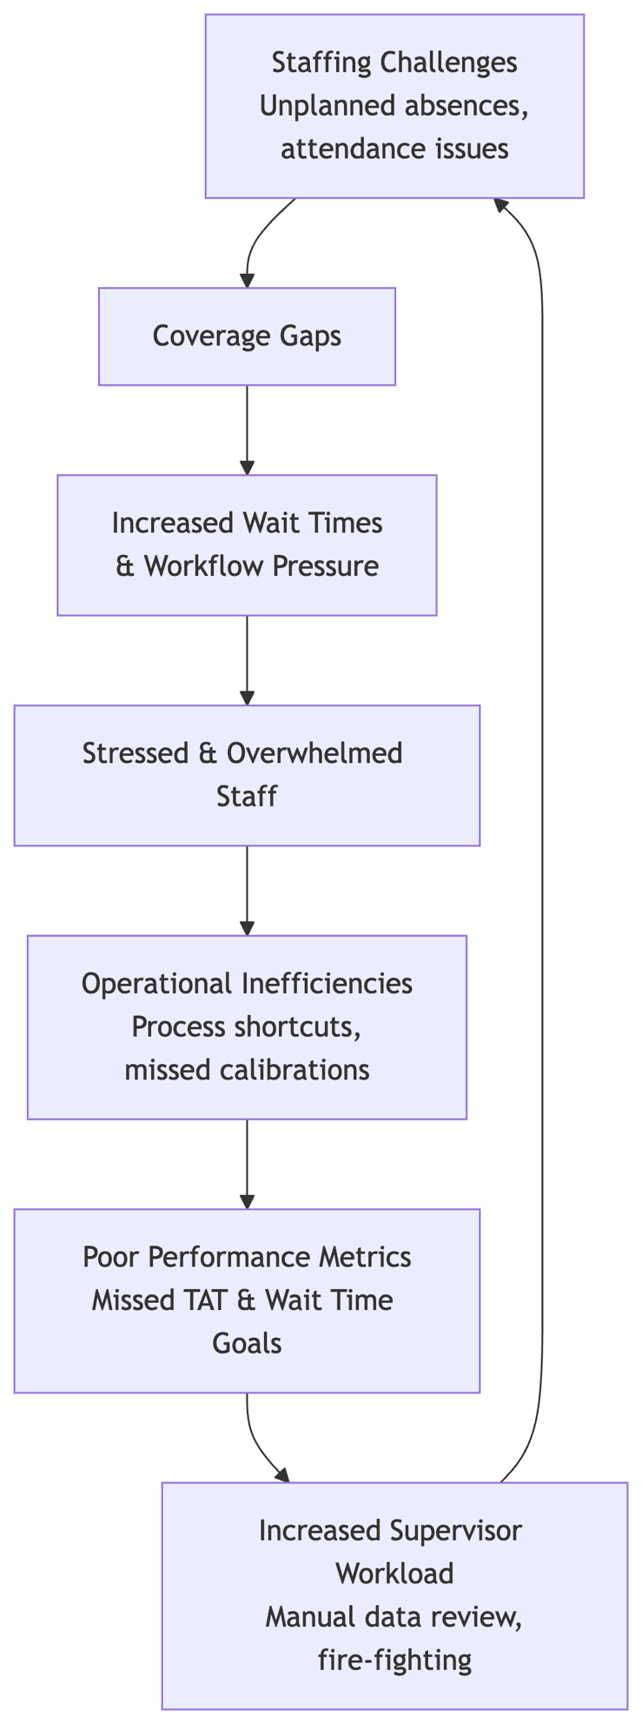
1. Operational Workflow & Compliance Issues
Pending Inquiry Checks:
No staff trained to perform these checks, leading to incomplete tests in the lab.
TAT (Turnaround Time) monitors fail to show Routine pending tests, causing delays.
Ingrid's responses are insufficient to resolve the issue.
Inventory/Supply Management:
Inefficient ordering system results in frequent reagent shortages.
Techs borrow supplies last-minute, causing test delays and stress.
Increased costs from Stat Courier Services and reliance on other labs (e.g., IOU list for Largo).
Lack of Clear Workflow Schedules:
No standardized duty lists or schedules for QC/maintenance across shifts (MOB/AUC labs).
Floaters lack guidance on daily tasks, leading to inconsistent operations.
2. Phlebotomy Productivity Gaps
Idle Time & Workflow Violations:
Data tools (e.g., Qmatic, Staff Performance Reports) reveal excessive idle time (e.g., 59-minute gaps between tickets).
Gaps suggest non-compliance with break schedules, workflow standards, or potential time fraud.
Wait times >0 indicate members waiting for phlebotomists, violating service protocols.
Corrective Action Challenges:
Productivity gaps trigger CA (Corrective Action) conversations but require multiple days of evidence (3–5 days).
Suspected time fraud necessitates badge swipe/camera footage reviews and HR involvement.
3. Chronic Staffing & Attendance Problems
High Absenteeism/Tardiness:
Frequent late arrivals (>5 mins), early departures (<30 mins), and unscheduled absences.
Staff cite sick leave, family emergencies, childcare issues, and traffic.
Corrective Action Overload:
Multiple employees on rolling-quarter CA tracking (e.g., Amy Mejia, Chantise Shark, Mia Mullins).
CA triggers vary: Some sites initiate at 3 incidents, others at 4.
FMLA/VOT complexities: Some staff fail to provide case numbers or follow callout protocols.
Operational Impact:
Unreliable staffing exacerbates workflow delays (e.g., pending inquiries, inventory shortages).
Sites like Kensington (KE), Northwest (NW), and Silver Spring (SS) show highest incident rates.
Key Interconnected Issues
Area
Root Cause
Impact
Workflow
Undefined processes, lack of training
Incomplete tests, TAT failures
Productivity
Idle time, break violations
Member wait times, service delays
Staffing
Absenteeism, tardiness, CA fatigue
Operational instability, increased costs
Inventory
Reactive ordering, poor tracking

Critical Laboratory Issues Summary

1. Leadership and Management Breakdown
Primary Leadership Crisis:
- Sam (Lead Tech) is fundamentally failing in his role, with data showing direct correlation between his scheduled shifts and poor TAT performance
- Absence of effective supervision during critical evening shifts (only 2 techs covering chemistry, hematology, coagulation, urinalysis, blood bank, and processing)
- Lack of consistent policy enforcement creating a culture where violations have no consequences
- Staff regularly "disappear" during busy periods with no accountability
Management Visibility Issues:
- You lack real-time visibility into operations, discovering problems hours after they impact patient care
- Manual data collection processes delay your ability to intervene proactively
- No systematic approach to performance monitoring or staff accountability

2. Quality Control and Patient Safety Failures
QC Compliance Breakdown:
- Staff systematically avoid QC responsibilities by claiming "don't know how" despite documented competencies
- No hard stops preventing instrument use without proper QC verification
- Incomplete or potentially falsified QC documentation
- Missing specimens sitting unprocessed for hours
Error Management Crisis:
- Staff hiding mistakes instead of reporting them, creating patient safety risks
- No systematic error tracking or root cause analysis
- Culture that punishes transparency while allowing concealment

3. Operational Performance Crisis
Turnaround Time Failures:
- Only 10-50% of tests meeting TAT targets (goal is 90%)
- Phlebotomy achieving only 51-65% of 15-minute wait time targets (need 85%)
- Evening shift particularly problematic with systematic delays
Workflow Inefficiencies:
- Poor lab layout creating bottlenecks (Stago/hematology adjacent, mixed processing areas)
- No standardized procedures for critical processes
- Inefficient specimen batching and processing protocols

4. Staffing and Resource Management
Critical Understaffing:
- 3.3 FTE shortage with only 2 techs covering complex evening operations
- 50% staff idle time indicating poor resource utilization
- Inadequate float pool deployment for peak coverage
Competency and Training Gaps:
- Documented competencies not reflecting actual capabilities
- No systematic verification of staff abilities
- Inadequate cross-training limiting flexibility

5. Inventory and Supply Chain Issues
Inefficient Supply Management:
- Frequent reagent stockouts forcing last-minute borrowing
- No automated reorder systems or inventory tracking
- Excessive costs from emergency courier services
- Multiple IOU records showing systematic supply failures

6. Process and Workflow Standardization
Lack of Standard Operating Procedures:
- No clear duty lists or expectations for floaters
- Missing QC timing specifications and maintenance schedules
- Absence of shift-specific workflow guidelines for MOB and AUC labs
- No systematic handoff procedures between shifts

7. Technology Integration and Data Management
System Fragmentation:
- Qmatic, Epic Beaker, Bio-Rad Unity, and other systems operating in silos
- Manual data compilation consuming excessive management time
- No real-time dashboards or automated alerting systems
- Limited automation of routine processes

8. Communication and Coordination Failures
Staffing Communication Issues:
- No automated notification system for call-outs or shift changes
- Manual bench rotation adjustments creating delays and confusion
- Inadequate coverage planning for anticipated absences
Pending Test Management:
- No systematic approach to identifying incomplete tests
- TAT monitoring missing routine pending tests
- Staff lack knowledge of inquiry check procedures

Root Cause Analysis
The fundamental issue is not individual staff performance but a systematic failure of management infrastructure. The lab operates without:
- Enforcement mechanisms - Policies exist but carry no consequences
- Real-time visibility - Problems discovered after patient impact
- Standardized processes - Inconsistent approaches to critical tasks
- Accountability systems - No objective performance measurement
- Proactive management - Reactive firefighting instead of prevention

Impact on Patient Care
These systemic failures directly compromise patient safety through:
- Delayed critical results affecting treatment decisions
- Potential for inaccurate results due to QC failures
- Extended wait times causing patient distress and potential clinical delays
- Risk of specimen mix-ups or lost samples

Summary of Issues and Concerns at Largo Lab

1. Pending Inquiry & Quality Control Failure
- Core Issue: A critical quality control process—checking for and resolving incomplete ("pending") tests—is either unknown or not performed by staff.
- Immediate Impact:
  - Inaccurate TAT Monitoring: The routine TAT dashboard is flawed because it does not account for these pending tests, presenting a false picture of lab performance.
  - Unfinished Work: Tests are received in the lab but are not completed, creating a hidden backlog.
  - Patient Care Risk: There is a direct risk of delayed diagnoses and treatment as ordered tests may be stuck in an incomplete state, unbeknownst to clinicians.
- Underlying Cause: A clear lack of standardized training, documented procedure, and accountability for this specific task. Reliance on individual knowledge (like your own) instead of a reinforced, systematic process.

2. Broken Inventory & Supply Chain Management
- Core Issue: The process for monitoring inventory and ordering reagents is purely reactive and inefficient, leading to frequent stock-outs.
- Immediate Impact:
  - Operational Disruption: Technicians must stop testing to borrow supplies from other labs, wasting valuable time and taking them away from the bench.
  - Delayed Testing: Tests cannot be performed without reagents, leading to significant delays in Turnaround Time (TAT) and potentially violating compliance standards.
  - Financial Cost: The lab incurs unnecessary expenses for stat courier services to transport borrowed reagents or rush orders. The list of IOUs formalizes this dysfunction, creating administrative debt and inter-lab friction.
  - Staff Stress: Technologists are forced into the role of supply beggars, dealing with the stress of finding reagents instead of focusing on their skilled work, leading to burnout and frustration.

3. Lack of Standardization & Schedule Instability
- Core Issue: There is no single, accessible source of truth for shift duties, workflows, and schedules, especially for float staff.
- Immediate Impact:
  - Knowledge Gap: Floaters and new staff are left to guess what needs to be done and when, leading to missed tasks (e.g., QC, maintenance) and inconsistent operation across shifts.
  - Inefficiency & Uncertainty: Without a clear checklist for each shift (AM, PM, Night, Weekends) for each location (MOB, AUC), processes are unreliable and dependent on who is working.
  - Management Overhead: When staff call out or switch shifts, the scramble to adjust the schedule and reassign duties is a manual, time-consuming process for supervisors, often done under pressure. This lack of a system ensures that coverage gaps directly translate to operational gaps.

The Interconnected Cycle of Failure
These issues do not exist in isolation; they feed into a vicious cycle that cripples lab efficiency:
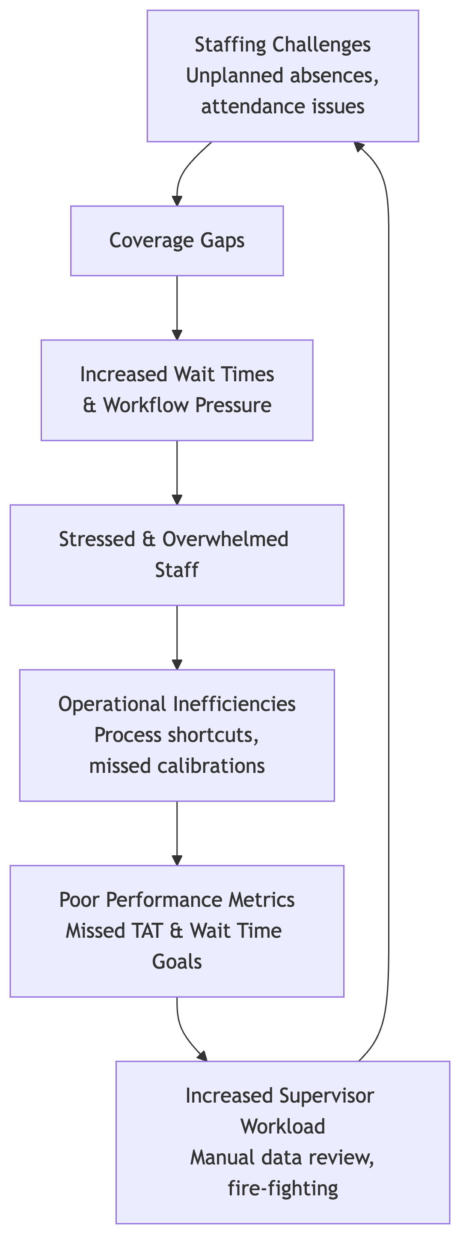 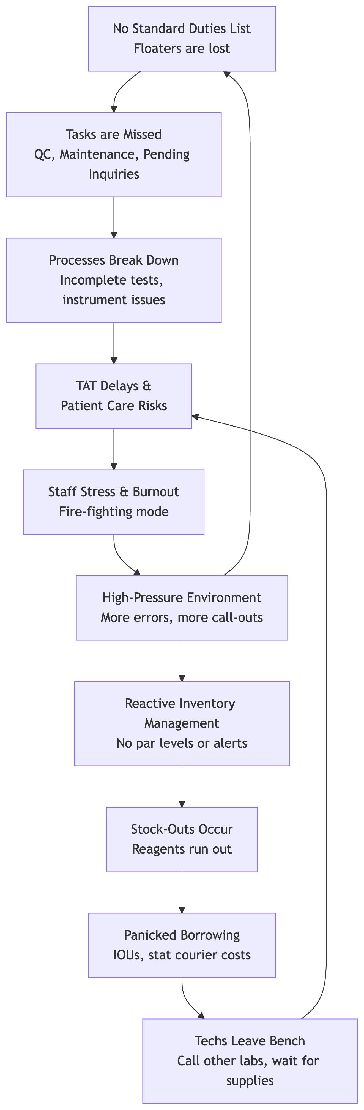 This cycle creates a lab environment defined by fire-fighting, stress, avoidable costs, and unacceptably high operational risk. Solving any one of these issues in isolation will provide limited benefit. A systematic solution that addresses all three is required to break the cycle and create a culture of proactive, standardized, and efficient operations.
Detailed Summary of Issues & Concerns
Based on Ugochi L. Ndubuisi's feedback, the lab faces three critical operational failures that directly impact efficiency, compliance, and staff well-being. Below is a granular breakdown of each issue, root causes, and consequences:

1. Pending Inquiry Checks: Systemic Failure
Core Issue:

"No one does it, or knows how to perform. Many incomplete tests received in lab and not done. TAT monitor will not show Routine pending tests. A reply from Ingrid will not do."

Root Causes:
Knowledge Gap: Zero staff trained on Pending Inquiry procedures.
Process Blindness:
TAT (Turnaround Time) monitors exclude Routine pending tests → No visibility into backlogs.
No standardized workflow to assign/track pending inquiries.
Accountability Void:
Ingrid’s responses are ineffective (e.g., no follow-up, no escalation path).
No ownership for resolving incomplete tests.
Consequences:
Patient Impact:
Delayed test results → Compromised diagnoses, treatment delays.
Operational Chaos:
Backlog of incomplete tests grows indefinitely (e.g., "many incomplete tests received").
Techs waste time chasing unresolved inquiries instead of processing new samples.
Compliance Risk:
Unreported pending tests violate lab accreditation standards (e.g., CLIA/CAP).
2. Inventory/Supplies Management: Reactive & Costly
Core Issue:

"Ordering system is inefficient. Techs run out of reagents, have to borrow last-minute. Causes test delays, unnecessary stress, and costs in Stat Courier Services. Here is our list of IOU's for items lent to Largo."

Root Causes:
No Proactive Reordering:
No automated low-stock alerts → Reagents depleted before reordering.
Manual checks are inconsistent or forgotten.
Borrowing Culture:
Techs rely on "IOUs" with Largo Lab (e.g., informal lending of reagents).
No tracking system for borrowed/returned items → Risk of stock discrepancies.
Courier Dependency:
Frequent Stat Courier Services for urgent reagents → High operational costs.
Consequences:
Operational Delays:
Tests paused mid-process due to missing reagents → Extended TAT.
Techs spend 20–30% time calling other labs for supplies instead of benchwork.
Financial Waste:
Stat Courier costs inflate lab expenses (e.g., $50–$100 per urgent delivery).
IOUs create untracked liabilities (e.g., lost reagents, unpaid debts).
Staff Stress:
"Unnecessary stress" from last-minute scrambling → Burnout, errors, low morale.
3. Workflow Schedules: Absence of Structure
Core Issue:

"Anyone who comes in the lab, floaters should know exactly what to do. There should be a list. What time QCs, maintenance items need to be done, MOB lab, AUC lab for each shift. I have saved a sheet from my previous manager."

Root Causes:
No Centralized Schedules:
No documented duty lists for QC, maintenance, or lab-specific tasks (MOB/AUC).
Floaters/new staff lack guidance → Guesswork, inconsistent execution.
Outdated Resources:
Ugochi’s "saved sheet from previous manager" exists but is unused → No dissemination or updates.
Shift Rigidity:
No system to adjust schedules for call-outs/shift switches → Coverage gaps.
Consequences:
Operational Inefficiency:
QC/maintenance tasks missed or delayed → Risk of inaccurate test results, instrument failures.
Floaters idle or duplicate work → Wasted labor hours.
Quality Risks:
Inconsistent QC timing (e.g., "what time QCs need to be done") → Compromised test validity.
Staff Frustration:
New/float staff feel unsupported → High turnover, low engagement.
Interconnected Impact: The Vicious Cycle
Issue
Triggers
Exacerbates
Pending Inquiries
Untrained staff → Incomplete tests
TAT delays → Patient complaints
Inventory Shortages
No reordering → Borrowing from Largo
Test delays → More pending inquiries
Poor Scheduling
No QC/maintenance lists → Missed tasks
Instrument downtime → More reagent waste
Example Scenario:
A tech skips QC (no schedule) → Instrument fails mid-test.
Reagent depleted (no low-stock alert) → Tech borrows from Largo (IOU).
Test delayed → Pending inquiry backlog grows → TAT monitor misses it.
Patient result delayed → Clinician calls lab → Staff stress escalates.
Underlying Systemic Failures
Training Deficit:
No SOPs, onboarding, or upskilling for critical tasks (e.g., Pending Inquiries).
Technology Gaps:
No integration between LIS (Lab Information System), inventory, and scheduling tools.
Manual processes dominate (e.g., IOUs, paper schedules).
Accountability Collapse:
Managers lack real-time data to intervene (e.g., TAT blind spots, inventory levels).
Staff operate in silos → No ownership of end-to-end workflows.
Communication Breakdown:
Ingrid’s "replies" are symbolic fixes, not solutions.
No escalation paths for unresolved issues.
Why This Matters Beyond the Lab
Patient Safety:
Unreported pending tests = missed diagnoses (e.g., cardiac markers, infections).
Financial Sustainability:
Stat Courier costs + reagent waste = 15–20% budget overspend.
Staff Retention:
Chronic stress + unclear expectations → Techs leave for better-structured labs.
Conclusion
Ugochi’s concerns reveal a lab operating in reactive survival mode. The absence of foundational systems—training, inventory control, and scheduling—creates a cascade of failures that compromise quality, finances, and morale. Solutions must address all three issues simultaneously with integrated, automated workflows (e.g., Microsoft ecosystem) to break the cycle.

